PAYMENT GUARANTEE LETTER (PGL)
& IRREVOCABLE MASTER DISBURSEMENT & PAYMENT AGREEMENT (IMDPA)
I, Guy XXXXXXXXX, CEO ofXXXXXXX, hereby confirm the responsibility that we will identify the funds of the subject contract of €168,000,000,00 (ONE HUNDRED SIXTY EIGHT MELLON Euros).
I, Guy XXXXXXXXX, CEO ofXXXXXXX, hereby confirm that we are READY, WILLING AND ABLE (RWA) to download and make payment against the above said €168,000,000,00 (ONE HUNDRED SIXTY EIGHT MELLON EURO), transferred to our Attorney IOLTA Account (as specified herein below) by MT 103 SWIFT Direct Wire
Transfer/GPI AUTOMAT.
I, Guy XXXXXXXXX, CEO ofXXXXXXX, hereby confirm that once the funds are cleared, we will send this PAYMENT GUARANTEE LETTER (PGL) to the nominated accounts’ bank officer in this PGL by officially bank secure email and one soft copy to BENEFICIARY (named below) and his banker/paymaster.
I, Guy XXXXXXXXX, CEO ofXXXXXXX, hereby confirm that once the transfer has been successfully completed, the payment will be made to all nominees and payment receiving beneficiaries as per this PGL via SWIFT MT103 DIRECT / WIRE TRANSFER within 72 hours. Copies of the transfer slips will be made immediately available to BENEFICIARY (named below) and his banker/paymaster.
I, Guy XXXXXXXXXX CEO XXXXXXXXXXXXX (XXXXXXXXXXXXX),hereby irrevocably and unconditionally, without protest or notification, without prejudice, recourse, or delay, guarantee the payment in the below nominated percentages from 100% (One Hundred Percent) of each Transaction, including any Rolls and Extensions. This AGREEMENT is our irrevocable pay order to the BENEFICIARY, and it is and shall remain an intricate part of the AGREEMENT between BENEFICIARY and RECEIVER.
All disputes and questions whatsoever which arises between the PARTIES to this AGREEMENT and touching on this AGREEMENT on the construction or application thereof or any account cost, liability to be made hereunder or as to any act or way relating to this AGREEMENT shall be settled by the arbitration in accordance with the arbitration ICC laws.
This AGREEMENT, if transmitted by facsimile or electronic mail shall be considered an original, legally enforceable document. Generally recognized International Standards of Non-Circumvention and Nondisclosure are applicable for a period of Five Years from the date of this document or the last date of the contract including any renewals, extensions and additions are fully completed and we agree to respect those.
The above stated codes and any other identification codes shall remain the same and shall not be changed until this transaction including any renewals, extensions and additions are fully completed and we agree to respect those. The transaction code may be amended only by AGREEMENT between all PARTIES hereto. This AGREEMENT will come into effect only after full money transfer as of the AGREEMENT will happen.
This AGREEMENT shall be lodged in our bank and a copy will be forwarded to the BENEFICIARY. I agree to the above irrevocable investment distribution payment AGREEMENT in its entirety.
This AGREEMENT once executed by the RECEIVER, THE LABYRINTH GROUP will become effective as of the date stated below. Any official notices exchanged by BENEFICIARY or RECEIVER, shall be sent to the first mentioned address herein or as may be attached by addendum hereto; a facsimile or electronically transferred copy duly signed by both BENEFICIARY and RECEIVER shall be deemed original.
Senders will be provided with Immunity Bank Accounts. These accounts come with special protections and cannot be blocked or interfered with. They can receive unlimited amounts, and are multi-currency.
Senders will be provided with optional Trust structures for further protections, ease of transferring funds between countries, and tax benefits. These Trusts are recognized in most countries. They are 100% tax deferred, unlimited in assets, and can contain multiple companies and projects.
Clients will be given the option to further enhance their earnings with Trade Programs.
Clients from outside the US will be given the option to
SERVER SERIAL ID: | dns3.ambank.com.my/
WTS SERVER | https://www.ambank.com.my
CLIENT NAME: | PRATHABAN PALPANATHAN
TRANSACTION CODE ID: | TPPENT-PRATHABAN-007
TRANSACTION CODE: | TPPENT-Prathaban-007
COMMON ACCOUNT NO.: | 8881050396671
SORT CODE: | 043
RECEIVING SERVER IP: | 203.223.145.152
USER NAME: | Prathaban A/L Palpanathan
USER ID: | Loharr22T
FARM | 41,42@107
CURRENCY: | Multi Currency
SENDER:
 | Details of Bank Account
 | COMPANY NAME: | TP PRATHABAN ENTERPRISES
 | COMPANY ADDRESS: | 70,LRG 9,TAMAN MACHANG BUBUK,14020,BUKIT MERTAJAM,P.PINANG
 | COMPANY REG №: | PG0409450-W
 | BANK NAME: | AMBANK (M) BERHAD
 | BANK ADDRESS: | Ground & First Floor, No. 1394, Jalan Padang Lalang, 14000 Bukit Mertajam, Pulau Pinang
 | SWIFT CODE : | ARBKMYKLXXX
 | SWIFT GPI CODE: | ARBKMYKL001
 | ACCOUNT NAME: | TP PRATHABAN ENTERPRISE
 | ACCOUNT NUMBER: | 8881050396671
 | IBAN CODE: | 8881050396671
 | BANK OFFICER: | VICTOR LIM
 | BANK OFFICER TEL: | +6045302391
 | BANK OFFICER EMAIL: | Bm043@ambankgroup.com,,customercare@ambankgroup.com
 | BRANCH: | BUKIT MERTAJAM
 | ISIN: | AS24218
 | IDENTITY CODE: | PRATHABANPALPANATHAN-0001000549111
 | GLOBAL SERVER ID: | 203.223.145.152
 | GLOBAL SERVER IP: | 203.223.145.152
RECEIVER:

BENEFICIARY 1: XXX: SHALL RECEIVE TEEN PERCENT (10%) OF PAYMENT OF FACE VALUE OF COMPLETED INVESTMENT €168,000,000,00 (ONE HUNDRED SIXTY EIGHT MELLON EURO). In other words, Mr. XXX will receive €16,800,000 (SIXTEEN MELLON EIGHT HUNDRED THOUSAND EURO) INCLUDING ANY ROLLS AND EXTENSIONS, TO BE FORWARDED TO THE FOLLOWING WALLET .
TSa9ZTgUmES7pEXy4YM14cqMWqhnCe8u7t
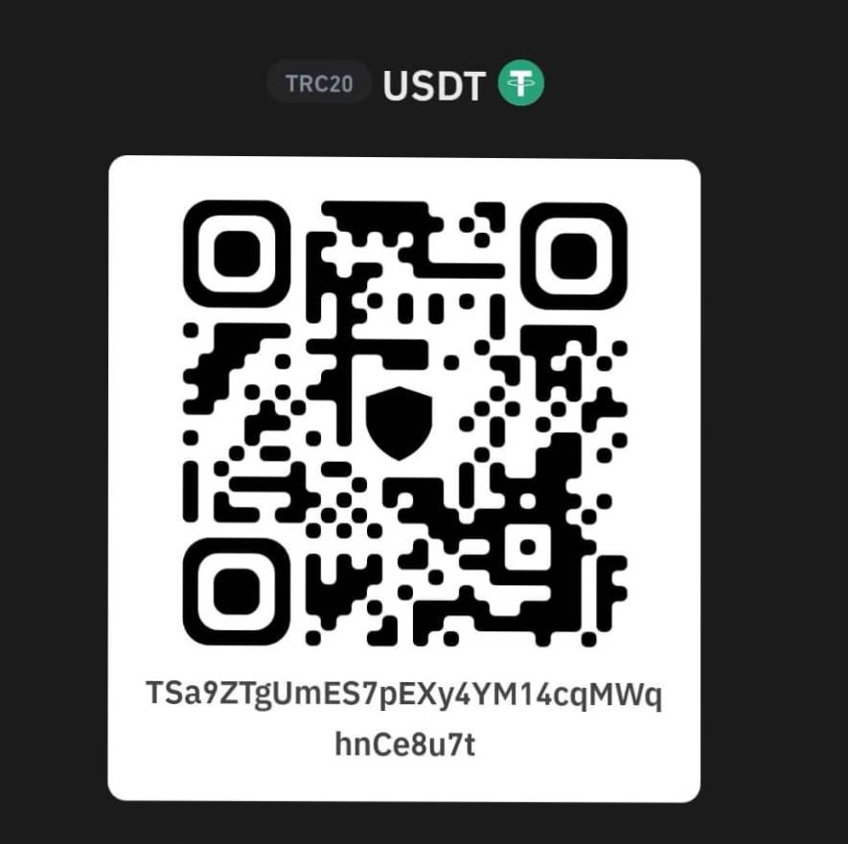

BENEFICIARY 2: XXX: SHALL RECEIVE TWELVE POINT FIVE PERCENT (12.5%) OF PAYMENT OF FACE VALUE OF COMPLETED INVESTMENT €168,000,000 (ONE HUNDRED SIXTY EIGHT MELLON EURO). In other words, Mr. XXX will receive €21,000,000 (TWOINTY ONE MELLON EURO) INCLUDING ANY ROLLS AND EXTENSIONS, TO BE FORWARDED TO THE FOLLOWING WALLET:
TXxBpQsVu64Z6mvNiAEe29yM6ycyiTXXBK

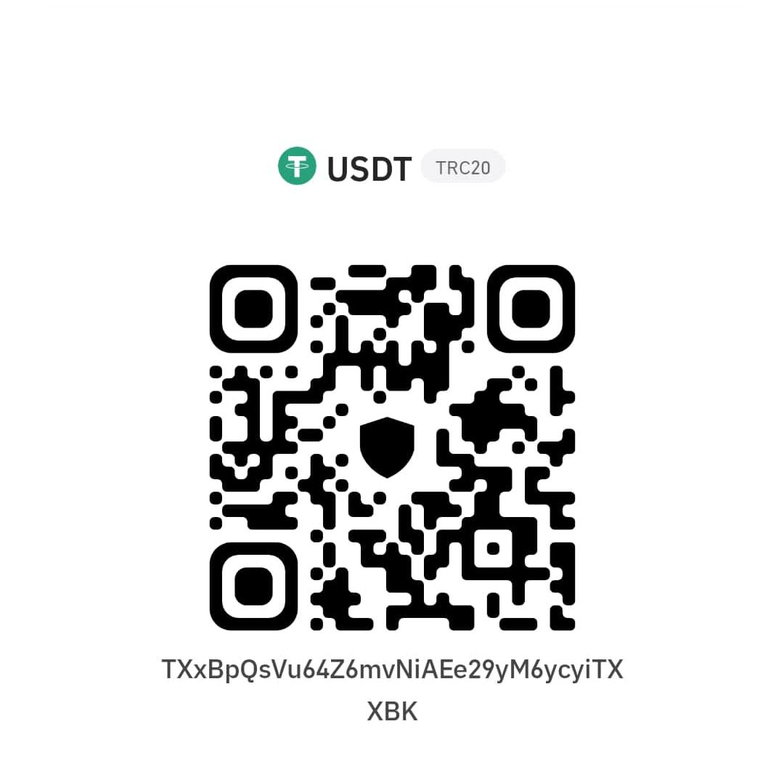

BENEFICIARY 3: XXX: SHALL RECEIVE TWELVE POINT FIVE PERCENT (12.5%) OF PAYMENT OF FACE VALUE OF COMPLETED INVESTMENT €168,000,000 (ONE HUNDRED SIXTY EIGHT MELLON EURO). In other words, Mr. XXX will receive €21,000,000 (TWOINTY ONE MELLON EURO)INCLUDING ANY ROLLS AND EXTENSIONS, TO BE FORWARDED TO THE FOLLOWING WALLET:
COMPANY NAME: | Alpha HighQuest GMBH
COMPANY ADDRESS | Grafenauweg 10, 6300 Zug, Switzerland Place of Incorporation  Switzerland
Identification Number (UID) | CHE-202.644.899
Last Name: | RUBIN
First and Middle Name: | Michael Jeffrey
Country of Citizenship: | United States
Passport Number: | 488804181
Date of Issue: | 10 September 2012
Telephone Number: | +1 (617) 417-1749
Email Address: | rubinmj@gmail.com
Bank Name: Branch Name: | UBS AG  (HEAD OFFICE)
Address: | BAHNHOFSTRASSE 45 8098 Zurich, Switzerland
Branch Code: | 80A
SWIFT / BIC: | UBSWCHZH80A
Account Name: | ALPHA HIGHQUEST GMBH
Account Number IBAN | UBS Current Account – CHF 0273 00148429.01R CH08 0027 3273 1484 2901 R UBS Current Account – USD 0273-00148429.60G CH85 0027 3273 1484 2960 G  UBS Current Account – GBP 0273-00148429.61P CH52 0027 3273 1484 2961 P

Signed by the RECEIVER
COMPANY: International Group for Mining & Petroleum & Derivatives and Construction (IGM) Corp.
REPRESENTED BY: Mahmoud Mohamed Nazif Mohamed
PASSPORT: A27569764
ISSUE DATE: 03/10/2020
I, GUY XXXXXXXXX, CEO ofXXXXXXX, hereby swear that the information provided in this PGL is

SENDER - PASSPORT COPY:
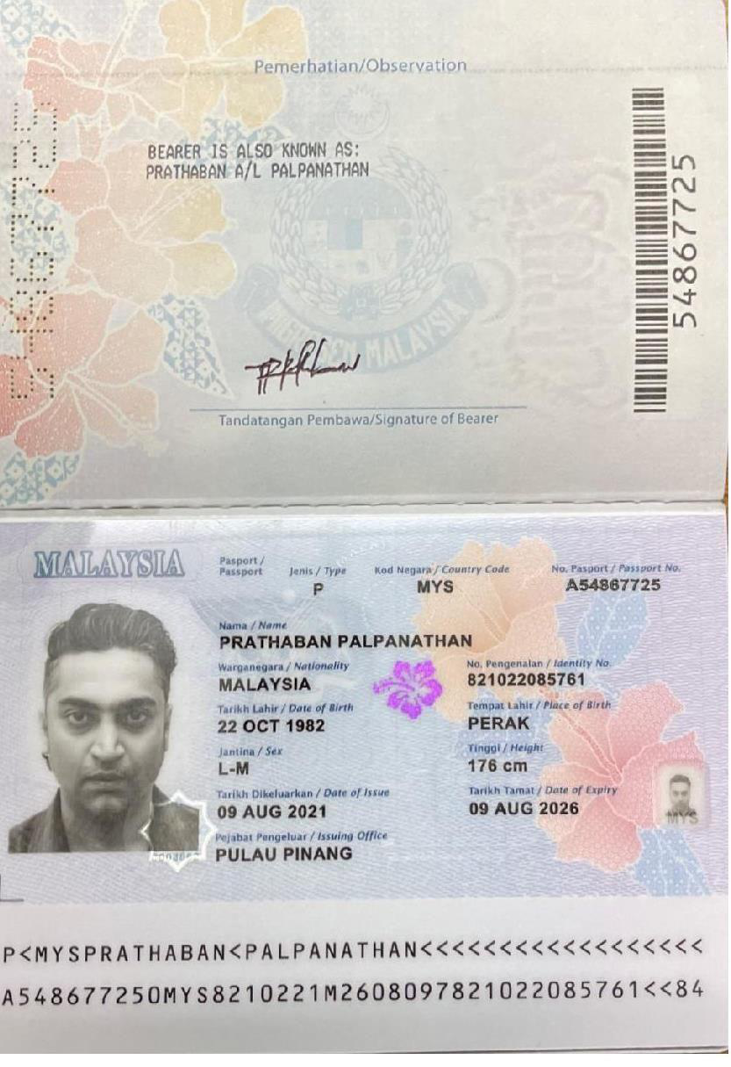

RSERVES -PASSPORT COPY

30 Gould St. Suite R
Sheridan, WY 802801-6517 USA

EDT (ELECTRONIC DOCUMENT TRANSMISSIONS)
EDT (Electronic Document Transmissions) shall be deemed valid and enforceable in respect to any provisions of this Contract. As applicable, this AGREEMENT shall:
- Incorporate U.S. Public Law 106-229, ‘‘Electronic Signatures in Global & National Commerce
Act’’ or such other applicable law conforming to the UNCITRAL Model Law on Electronic Signatures (2001)
- Incorporate ELECTRONIC COMMERCE AGREEMENT (ECE/TRADE/257, Geneva, May 2000) adopted by the United Nations Centre for Trade Facilitation and Electronic Business ( UN/ CEFACT).
- EDT documents shall be subject to European Community Directive No. 95/46/EEC, as applicable. Either Party may request a hard copy of any document that has been previously transmitted by electronic means provided however, that any such request shall in no manner delay the PARTIES from performing their respective obligations and duties under EDT instruments.
IN WITNESS WHEREOF, the undersigned PARTIES have read this document and have taken legal advice of its legality, and after understanding the content of this AGREEMENT written in the English language, by knowledge of the language or by professional translation to the Party!s language, initialed all the pages of this AGREEMENT (including its Annexes) and fully understand and agree that its execution constitutes an acceptance of all of its mutually protective covenants, terms, conditions, procedures and is lawfully binding upon both PARTIES, their legal heirs, successors, representatives and assignees. ——— END OF DOCUMENT ———

